**TRINITY INTERNATIONAL SS & COLLEGE**

**Dillibazar Height, Kathmandu, Nepal**



**PROJECT WORK**

**Personal Website using HTML and CSS**

**SUBMITTED BY: SUBMITTED TO:**

**NAME: Prashim Timsina**

**GRADE: XI (MC1)** 

**DATE : [22nd April 2023] PRAVEEN KOIRALA**

**Faculty of Computer Science**

**KATHMANDU, NEPAL**

**2023**

A Project Work On

**HTML & CSS**

Submitted as a partial fulfillment of requirement of the curriculum of

GRADE-XI (Computer Science) under NEB

Submitted By:

**Prashim Timsina**

Under Supervision Of

**PRAVEEN KOIRALA**

Date:

**[22nd April 2023]**



**TRINITY INTERNATIONAL SS & COLLEGE**

Dillibazar Height, Kathmandu, Nepal

ACKNOWLEDGEMENT

I would like to express my deep appreciation and gratitude to my subject teacher Mr. Praveen Koirala for his coinstantaneous help, advice, information and encouragement in this project

I feel immense pleasure to present my project after a long work. Besides my effort, the help and guideline given by many others hasn’t been unnoticed. I express my gratitude to all those countless people for the support for me in doing this project.

I express my thanks to Trinity International College for it has been a source of the creation of this project and the support, valuable information, resources and guidance give to me to do this project.

I am also grateful and indebt of my beloved friends for their immeasurable help, support and encouragement from the beginning to the end of the project without whom this project would not have been a reality.

Last but not the least I would like to thank my parents, family members, friends, this College and other who help me for their guidance and support.

**[Prashim Timsina]**

**[22nd April 2023]**

**Table of Contents**

S. No. Page No.

1. Acknowledgement I

2. Table of Contents II

3. Project Description (1-2)

3.1 Introduction 1

3.1.1 Concept of Web 1

3.1.2 HTML and CSS 1

3.2 Web Architecture 2

3.3 Source Code (3-27)

3.4 Output/Web site (28-30)

4. Conclusion 30

**3. Project Description**

This project aims to explore the concept of web development by creating a web architecture using HTML and CSS. In today's digital age, having a strong online presence has become crucial for businesses and individuals alike. Websites provide a platform to showcase products, services, and skills to a global audience. Therefore, it is essential to understand the fundamentals of web development to create a successful online presence.

**3.1 Introduction:**

The project will begin with an introduction to the concept of the web and its importance in today's world. The internet has become an indispensable part of our lives, enabling us to access vast amounts of information, communicate with people from all over the world, and conduct business operations online. The concept of web development will be explored, and the different components of a web page will be discussed. HTML and CSS will be introduced as the primary technologies used to create web pages.

**3.1.1 Concept of Web:**

The concept of web refers to a network of connected computers and servers that allow for the sharing of information and resources. The web has revolutionized the way people interact, communicate, and conduct business. Today, having a website has become essential for businesses of all sizes to reach their target audience and grow their brand. In addition, the ability to create and maintain web pages is a valuable skill for individuals in various fields, including marketing, design, and development.

**3.1.2 HTML and CSS:**

HTML (Hypertext Markup Language) is the standard markup language used to create web pages. It provides a set of tags and attributes that allow developers to define the structure and content of a web page. CSS (Cascading Style Sheets) is used to style web pages, providing developers with a set of rules for formatting and layout. Together, these technologies form the backbone of web development and are essential for creating beautiful and functional websites.

**3.2 Web Architecture:**

The project will focus on creating a web architecture using HTML and CSS. The web architecture will be designed to be scalable, flexible, and efficient, using best practices in web development. The architecture will be modular, allowing for easy updates and maintenance.

The architecture will consist of several layers, including the presentation layer, the application layer, and the data layer. The presentation layer will be responsible for the visual presentation of the web page, using HTML and CSS to create the layout and styling. The application layer will handle the business logic of the web page, using JavaScript and other programming languages. The data layer will be responsible for storing and retrieving data from databases and other sources. But the following project has neither of JavaScript or Data layer.

**3.3 Source Code**

File Name: index.html

<!DOCTYPE html>

<html class="no-js">

  <head>

    <title>Mr. Prashim Timsina</title>

    <!-- favicon -->

    <link

      rel="shortcut icon"

      href=" ' assets\image\favicon.ico'        "

      type="image/x-icon"

    />

    <!-- meta -->

    <meta charset="utf-8" />

    <meta name="viewport" content="width=device-width, initial-scale=1" />

    <meta http-equiv="X-UA-Compatible" content="IE=edge" />

    <!-- stylesheets -->

    <link rel="stylesheet" href="  assets\css\bootstrap.min.css" />

    <link

      rel="stylesheet"

      href="  assets\font_icon\css\pe-icon-7-stroke.css"

    />

    <link rel="stylesheet" href="  assets\font_icon\css\helper.css" />

    <link rel="stylesheet" href="  assets\css\owl.carousel.css" />

    <link rel="stylesheet" href="  assets\css\owl.theme.css" />

    <link rel="stylesheet" href="  assets\css\animate.css" />

    <link rel="stylesheet" href="  assets\css\style.css" />

    <!-- google fonts -->

    <link

      href="http://fonts.googleapis.com/css?family=Dosis:200,300,400,500|Lato:300,400,700,900,300italic,400italic,700italic,900italic|Raleway:400,200,300,500,100|Titillium+Web:400,200,300italic,300,200italic"

      rel="stylesheet"

      type="text/css"

    />

    <script src="  assets\js/modernizr.js"></script>

  </head>

  <body id="body">

    <!-- Header area -->

    <header id="header">

      <div class="center text-center">

        <h1 class="bigheadline">Prashim Timsina</h1>

        <h4 class="subheadline">The Worst Full Stack Developer</h4>

      </div>

      <div class="bottom">

        <a

          data-scroll

          href="#navigation"

          class="scrollDown animated pulse"

          id="scrollToContent"

          ><i class="pe-7s-angle-down-circle pe-va"></i

        ></a>

      </div>

    </header>

    <!-- Navigation area -->

    <section id="navigation">

      <div class="container">

        <div class="row">

          <div class="col-xs-6">

            <div class="logo">

              <a data-scroll href="#body" class="logo-text">Prashim Timsina</a>

            </div>

          </div>

          <div class="col-xs-6">

            <div class="nav">

              <a

                href="#"

                data-placement="bottom"

                title="Menu"

                class="menu"

                data-toggle="dropdown"

                ><i class="pe-7s-menu"></i

              ></a>

              <div class="dropdown-menu">

                <div class="arrow-up"></div>

                <ul>

                  <li>

                    <a data-scroll href="#body"

                      >Home <i class="pe-7s-home"></i></a

                    ><span class="menu-effect"></span>

                  </li>

                  <li>

                    <a data-scroll href="#services"

                      >Service <i class="pe-7s-config"></i></a

                    ><span class="menu-effect"></span>

                  </li>

                  <li>

                    <a data-scroll href="#portfolio"

                      >Portfolio <i class="pe-7s-glasses"></i></a

                    ><span class="menu-effect"></span>

                  </li>

                  <li>

                    <a data-scroll href="#testimonial"

                      >Testimonial <i class="pe-7s-comment"></i

                      ><span class="menu-effect"></span

                    ></a>

                  </li>

                  <li>

                    <a data-scroll href="#contact"

                      >Contact <i class="pe-7s-help1"></i></a

                    ><span class="menu-effect"></span>

                  </li>

                </ul>

              </div>

            </div>

          </div>

        </div>

      </div>

    </section>

    <!-- Content Area -->

    <!-- services section -->

    <section id="services" class="service-area">

      <div class="container">

        <h2 class="block_title">Skills</h2>

        <div class="row">

          <div class="col-md-3 col-sm-6">

            <div class="services">

              <div class="service-wrap">

                <img

                  src="  assets\images\python.png       "

                  alt="Python Logo Image"

                  class="python"

                />

                <h3>Python</h3>

                <p>

                  A Python learner who is Learning and contributing to projects

                  as well.

                </p>

              </div>

            </div>

          </div>

          <div class="col-md-3 col-sm-6">

            <div class="services">

              <div class="service-wrap">

                <img

                  src="  assets\images\webdev.png       "

                  alt="WebDev Logo Image"

                  class="webdev"

                />

                <h3>Web Dev.</h3>

                <p>

                  Contributing to projects and learning in both frontend as well

                  as backend.

                </p>

              </div>

            </div>

          </div>

          <div class="col-md-3 col-sm-6">

            <div class="services">

              <div class="service-wrap">

                <img

                  src=" assets\images\cybersecurity.png     "

                  alt="Cybersecurity Logo Image"

                />

                <h3>Cybersecurity</h3>

                <p>

                  Cybersecurity learner willing to learn to protect people from

                  cyber crimes.

                </p>

              </div>

            </div>

          </div>

          <div class="col-md-3 col-sm-6">

            <div class="services">

              <div class="service-wrap">

                <img

                  src=" assets\images\student.png      "

                  alt="Student Logo Image"

                />

                <h3>Student</h3>

                <p>

                  Student who is enthuastic and and exploring wonders of

                  computer science.

                </p>

              </div>

            </div>

          </div>

        </div>

      </div>

    </section>

    <!-- services -->

    <!-- Portfolio Area -->

    <section id="portfolio" class="portfolio-area">

      <div class="container">

        <h2 class="block_title">My Works</h2>

        <div class="row port cs-style-3">

          <div class="col-md-4 col-sm-6 col-xs-12 item-space">

            <figure>

              <img src="  assets/images/portfolio1.jpg     " alt="img04" />

              <figcaption>

                <h3>SRCN</h3>

                <p>

                  I was selected to work with<br />

                  Nepals top young minds.

                </p>

                <a

                  href="https://www.facebook.com/srcnepal"

                  class="button"

                  target="_blank"

                  >Take a look</a

                >

              </figcaption>

            </figure>

          </div>

          <div class="col-md-4 col-sm-6 col-xs-12 item-space">

            <figure>

              <img src="  assets/images/portfolio2.jpg       " alt="img01" />

              <figcaption>

                <h3>Gyan-e</h3>

                <p>

                  During my times at SRCN we<br />

                  developed a Q/A forum.

                </p>

                <a

                  href="https://thegyane.pythonanywhere.com/"

                  class="button"

                  target="_blank"

                  >Take a look</a

                >

              </figcaption>

            </figure>

          </div>

          <div class="col-md-4 col-sm-6 col-xs-12 item-space">

            <figure>

              <img src="  assets/images/portfolio3.jpg      " alt="img02" />

              <figcaption>

                <h3>LOFA</h3>

                <p>

                  I am currently working in LOFA<br />as a IT-Department Member

                </p>

                <a

                  href="https://facebook.com/lofanepal"

                  class="button"

                  target="_blank"

                  >Take a look</a

                >

              </figcaption>

            </figure>

          </div>

          <div class="col-md-4 col-sm-6 col-xs-12 item-space">

            <figure>

              <img src=" assets/images/portfolio4.jpg       " alt="img04" />

              <figcaption>

                <h3>One Quantum Nepal</h3>

                <p>

                  I am learning and working in a<br />

                  project with top quantum enthuasts.

                </p>

                <a href="https://onequantum.org" class="button" target="_blank"

                  >Take a look</a

                >

              </figcaption>

            </figure>

          </div>

          <div class="col-md-4 col-sm-6 col-xs-12 item-space">

            <figure>

              <img src=" assets/images/portfolio5.jpg      " alt="img01" />

              <figcaption>

                <h3>Org. Website</h3>

                <p>

                  While I am working in LOFA we <br />

                  developed a website for lofa.

                </p>

                <a href="https://lofanepal.org" class="button" target="_blank"

                  >Take a look</a

                >

              </figcaption>

            </figure>

          </div>

          <div class="col-md-4 col-sm-6 col-xs-12 item-space">

            <figure>

              <img src="  assets/images/portfolio7.jpg      " alt="img02" />

              <figcaption>

                <h3>Yet to do more things</h3>

                <p>Prashim Timsina</p>

                <!-- <a href="#" class="button">Take a look</a> -->

              </figcaption>

            </figure>

          </div>

          <div class="col-xs-12">

            <div class="btn-center">

              <a href="#" class="big button">View all</a>

            </div>

          </div>

        </div>

      </div>

      <!-- container -->

    </section>

    <!-- portfolio -->

    <!-- Testimonial Area -->

    <section id="testimonial" class="testimonial-area">

      <div class="container">

        <h2 class="block_title">Testimonials</h2>

        <div class="row">

          <div class="col-xs-12"></div>

          <div id="testimonial-container" class="col-xs-12">

            <div class="testimonila-block">

              <img

                src="  assets/images/testimonial.jpg       "

                alt="clients"

                class="selfshot"

              />

              <p>

                Lorem ipsum dolor sit amet, consectetur adipisicing elit. Quidem

                sed mollitia illum! Molestiae dignissimos, hic dolorem et eius

                ut nobis. Corrupti totam amet aperiam aut voluptate nobis dolor

                at soluta.

              </p>

              <strong>Shubham Jha</strong>

              <br />

              <small>UI/IX Designer</small>

            </div>

            <div class="testimonila-block">

              <img

                src="  assets/images/testimonial2.jpg        "

                alt="clients"

                class="selfshot"

              />

              <p>

                Lorem ipsum dolor sit amet, consectetur adipisicing elit. Quidem

                sed mollitia illum! Molestiae dignissimos, hic dolorem et eius

                ut nobis. Corrupti totam amet aperiam aut voluptate nobis dolor

                at soluta.

              </p>

              <strong>Lady Gaga</strong>

              <br />

              <small>Project Manager</small>

            </div>

            <div class="testimonila-block">

              <img

                src="  assets/images/testimonial3.jpg       "

                alt="clients"

                class="selfshot"

              />

              <p>

                Lorem ipsum dolor sit amet, consectetur adipisicing elit. Quidem

                sed mollitia illum! Molestiae dignissimos, hic dolorem et eius

                ut nobis. Corrupti totam amet aperiam aut voluptate nobis dolor

                at soluta.

              </p>

              <strong>Male Gaga</strong>

              <br />

              <small>Developer</small>

            </div>

          </div>

        </div>

      </div>

      <!-- container -->

    </section>

    <!-- testimonial -->

    <!-- Contact Area -->

    <section id="contact" class="mapWrap">

      <div id="googleMap" style="width: 100"></div>

      <div id="contact-area">

        <div class="container">

          <h2 class="block_title">Hey !!!</h2>

          <div class="row">

            <div class="col-xs-12"></div>

            <div class="col-sm-6">

              <div class="moreDetails">

                <h2 class="con-title">More About me</h2>

                <p>

                  Prashim Timsina is a student of Little Angels' School studying

                  in grade 9. Who is a computer enthusiast and is eager to

                  explore various fields of computer science. He at a very young

                  age is exploring various fields of computer science like web

                  development, networking, cybersecurity etc.

                </p>

                <ul class="address">

                  <li>

                    <i class="pe-7s-map-marker"></i

                    ><span

                      >Sanagaun, Patan,<br />Lalitpur, 44600,<br />Nepal</span

                    >

                  </li>

                  <li>

                    <i class="pe-7s-mail"></i

                    ><span>prashimtimsina92@gmail.com</span>

                  </li>

                  <li>

                    <i class="pe-7s-phone"></i><span>+977-984-529-7976</span>

                  </li>

                  <li>

                    <i class="pe-7s-global"></i

                    ><span><a href="#">My Website</a></span>

                  </li>

                  <li><button class="btn">Download CV</button></li>

                </ul>

              </div>

            </div>

            <div class="col-sm-6">

              <h2 class="con-title">Drop me a line</h2>

              <form action="#" method="POST">

                <div class="form-group">

                  <input

                    type="text"

                    class="form-control"

                    id="user_name"

                    placeholder="Enter your name"

                  />

                </div>

                <div class="form-group">

                  <input

                    type="email"

                    class="form-control"

                    id="your_email"

                    placeholder="Enter your email"

                  />

                </div>

                <div class="form-group">

                  <textarea

                    name="InputMessage"

                    id="user_message"

                    class="form-control"

                    rows="5"

                    required

                  ></textarea>

                </div>

                <button type="submit" class="btn medium">Let me know</button>

              </form>

            </div>

          </div>

        </div>

        <!-- container -->

      </div>

      <!-- contact-area -->

      <div id="social">

        <div class="container">

          <div class="row">

            <div class="col-xs-12">

              <ul class="scoialinks">

                <li class="normal-txt">Find me on</li>

                <li class="social-icons">

                  <a

                    class="facebook"

                    href="https://facebook.com/prashim.timsina.1"

                    target="_blank"

                  ></a>

                </li>

                <li class="social-icons">

                  <a

                    class="twitter"

                    href="https://twitter.com/TimsinaPrashim"

                    target="_blank"

                  ></a>

                </li>

                <li class="social-icons">

                  <a

                    class="linkedin"

                    href="https://www.linkedin.com/in/prashim-timsina-2aa167211/"

                    target="_blank"

                  ></a>

                </li>

                <li class="social-icons">

                  <a

                    class="google-plus"

                    href="https://instagram.com/prashim.py"

                    target="_blank"

                  ></a>

                </li>

                <li class="social-icons">

                  <a

                    class="wordpress"

                    href="https://github.com/Prashim-hack"

                    target="_blank"

                  ></a>

                </li>

              </ul>

            </div>

          </div>

        </div>

      </div>

      <!-- social -->

    </section>

    <!-- contact -->

    <!-- Footer Area -->

    <footer>

      <div class="container">

        <div class="row">

          <div class="col-sm-6">

            <p class="copyright">

              © Copyright 2021 <a href="#" target="_blank">Prashim Timsina</a>

            </p>

          </div>

        </div>

      </div>

    </footer>

    <!-- Necessery scripts -->

    <script src="  assets/js/jquery-2.1.3.min.js       "></script>

    <script src="  assets/js/bootstrap.min.js      "></script>

    <script src="https://maps.googleapis.com/maps/api/js?v=3.exp"></script>

    <script src="  assets/js/jquery.actual.min.js      "></script>

    <script src="  assets/js/smooth-scroll.js      "></script>

    <script src="  assets/js/owl.carousel.js       "></script>

    <script src="  assets/js/script.js       "></script>

  </body>

</html>

File Name: style.css

/* /////////////////////////////////////////////////////////////////////

//  01 - Universal

/////////////////////////////////////////////////////////////////////*/

html,

body {

  height: 100%;

}

body {

  font-family: "Lato", sans-serif;

}

h1,

h2,

h3,

h4,

h5,

h6 {

  font-family: "Dosis", sans-serif;

}

a {

  color: #e66f69;

  transition: 0.4s ease all;

  outline: none;

}

a:hover,

a:active,

a:focus {

  text-decoration: none;

  color: #e66f69;

  opacity: 0.9;

  outline: none;

}

.btn {

  color: #fff;

  background: transparent;

  border: 1px solid #fff;

  border-radius: 0px;

  font-size: 1.2em;

  transition: 0.4s ease all;

}

.btn:hover {

  background: #fff;

  color: #000;

}

.block_title {

  font-size: 4em;

  font-weight: 300;

  text-align: center;

  overflow: hidden;

  margin-bottom: 70px;

}

.block_title:before,

.block_title:after {

  content: "";

  background: #ccc;

  display: inline-block;

  height: 1px;

  position: relative;

  width: 42%;

  vertical-align: middle;

}

.block_title:before {

  right: 0.5em;

  margin-left: -42%;

}

.block_title:after {

  left: 0.5em;

  margin-right: -42%;

}

/* /////////////////////////////////////////////////////////////////////

//  02 - Header

/////////////////////////////////////////////////////////////////////*/

header {

  background: url(../images/bg.jpg) no-repeat;

  background-size: cover;

  background-attachment: fixed;

  background-position: 50% -50px;

}

.center {

  text-align: center;

  color: #fff;

}

.bigheadline {

  font-family: "Raleway", sans-serif;

  font-weight: 0;

  font-size: 10em;

  margin: 0;

}

.subheadline {

  font-family: "Titillium Web", sans-serif;

  font-weight: 200;

  font-size: 3em;

  margin: 0;

}

.scrollDown {

  font-size: 4em;

  color: rgba(255, 255, 255, 0.4);

  position: absolute;

  bottom: 10%;

  left: 49%;

}

.scrollDown:hover {

  color: rgba(255, 255, 255, 0.4);

  transition: 0.4s ease all;

}

/* /////////////////////////////////////////////////////////////////////

//  03 - Navigation

/////////////////////////////////////////////////////////////////////*/

#navigation {

  background: #111;

}

.nav-wrap {

  position: fixed;

  top: 0;

  width: 100%;

  z-index: 9999;

}

.logo {

  height: 76px;

  display: table;

  text-align: left;

}

.logo-text {

  font-size: 3em;

  padding: 0.2em 0;

  color: #fff;

  font-family: "Raleway", sans-serif;

  font-weight: 100;

  display: table-cell;

  vertical-align: middle;

}

.menu {

  float: right;

  font-size: 3em;

  color: #fff;

  padding-top: 10px;

}

.dropdown-menu {

  min-width: 240px;

  right: 0;

  left: auto;

  border: 1px solid #000;

  box-shadow: none;

  border-radius: 0px;

  margin-top: 5px;

}

.dropdown-menu ul {

  list-style: none;

  margin: 0;

  padding: 1em 2em;

  margin-top: 5%;

}

.dropdown-menu ul li {

  padding: 0.3em 0em 0.6em 0em;

  font-size: 1.3em;

  position: relative;

}

.dropdown-menu ul li a i {

  position: absolute;

  right: 0;

  top: 20%;

  font-size: 25px;

}

.arrow-up {

  width: 0;

  height: 0;

  border-left: 8px solid transparent;

  border-right: 8px solid transparent;

  border-bottom: 8px solid white;

  float: right;

  margin-top: -5%;

  margin-right: 23px;

}

/* /////////////////////////////////////////////////////////////////////

//  04 - Services

/////////////////////////////////////////////////////////////////////*/

.services {

  max-width: 293px;

  height: 263px;

}

.exp {

  padding-top: 76px;

}

.service-area {

  margin: 80px 0px 40px 0px;

}

.service-wrap {

  width: 100%;

  height: 100%;

  border: 1px solid #b5b5b5;

  text-align: center;

  display: block;

  border-radius: 50%;

}

.service-wrap img {

  margin-top: 40px;

  transition: all 0.3s ease;

  width: 100px;

}

.service-wrap .python {

  margin-top: 40px;

  transition: all 0.3s ease;

  width: 70px;

}

.service-wrap .webdev {

  margin-top: 40px;

  transition: all 0.3s ease;

  width: 80px;

}

.service-wrap:hover img {

  color: #e66f69;

}

.service-wrap p {

  padding: 0px 40px;

  font-size: 13px;

}

.service-wrap h3 {

  margin: 10px 0px;

}

.pe-dj {

  font-size: 5em;

}

/* /////////////////////////////////////////////////////////////////////

//  05 - Portfolio

/////////////////////////////////////////////////////////////////////*/

#portfolio {

  padding: 80px 0px 0px 0px;

}

.port {

  list-style: none;

  text-align: left;

  padding-bottom: 40px;

}

.port .item {

  display: inline-block;

  text-align: left;

  position: relative;

}

.port figure {

  margin: 0;

  position: relative;

}

.port figure img {

  max-width: 100%;

  display: block;

  position: relative;

}

.port figcaption {

  position: absolute;

  top: 0;

  left: 0;

  padding: 20px;

  background: #111;

  color: #e66f69;

}

.port figcaption h3 {

  margin: 0px 0px 8px 0px;

  padding: 0;

  color: #fff;

}

.port figcaption span:before {

  content: "by ";

}

.port figcaption a {

  text-align: center;

  padding: 8px 15px;

  display: inline-block;

  color: #fff;

}

.cs-style-3 figure {

  overflow: hidden;

}

.cs-style-3 figure img {

  -webkit-transition: -webkit-transform 0.4s;

  -moz-transition: -moz-transform 0.4s;

  transition: transform 0.4s;

}

.no-touch .cs-style-3 figure:hover img,

.cs-style-3 figure.cs-hover img {

  -webkit-transform: translateY(-50px);

  -moz-transform: translateY(-50px);

  -ms-transform: translateY(-50px);

  transform: translateY(-50px);

}

.cs-style-3 figcaption {

  height: 100px;

  width: 100%;

  top: auto;

  bottom: 0;

  opacity: 0;

  -webkit-transform: translateY(100%);

  -moz-transform: translateY(100%);

  -ms-transform: translateY(100%);

  transform: translateY(100%);

  -webkit-transition: -webkit-transform 0.4s, opacity 0.1s 0.3s;

  -moz-transition: -moz-transform 0.4s, opacity 0.1s 0.3s;

  transition: transform 0.4s, opacity 0.1s 0.3s;

}

.no-touch .cs-style-3 figure:hover figcaption,

.cs-style-3 figure.cs-hover figcaption {

  opacity: 1;

  -webkit-transform: translateY(0px);

  -moz-transform: translateY(0px);

  -ms-transform: translateY(0px);

  transform: translateY(0px);

  -webkit-transition: -webkit-transform 0.4s, opacity 0.1s;

  -moz-transition: -moz-transform 0.4s, opacity 0.1s;

  transition: transform 0.4s, opacity 0.1s;

}

.cs-style-3 figcaption a {

  position: absolute;

  bottom: 31px;

  right: 20px;

}

.button {

  background: transparent;

  border: 1px solid #fff;

}

.button:hover {

  background: white;

  color: #000;

}

.btn-center {

  display: block;

  padding: 80px 0px 60px 0px;

  text-align: center;

}

.big.button {

  border: 1px solid #000;

  font-size: 2em;

  color: #000;

  padding: 15px 30px;

}

.big.button:hover {

  background: #000;

  color: #fff;

}

.item-space {

  margin-bottom: 30px;

}

/* /////////////////////////////////////////////////////////////////////

//  06 - Testimonial

/////////////////////////////////////////////////////////////////////*/

#testimonial {

  background: url(../images/parallax.jpg);

  padding: 80px 0px 80px 0px;

  color: #fff;

  background-attachment: fixed;

  background-size: cover;

}

.testimonila-block {

  text-align: center;

}

.testimonila-block img {

  border-radius: 50%;

  border: 1px solid #000;

  max-width: 200px;

  max-height: 200px;

  margin-bottom: 30px;

}

.testimonila-block p {

  max-width: 60%;

  margin: 0 auto;

  margin-bottom: 20px;

  font-style: italic;

  font-size: 18px;

}

.testimonila-block strong {

  font-size: 2em;

}

/* /////////////////////////////////////////////////////////////////////

//  07 - Contact

/////////////////////////////////////////////////////////////////////*/

#contact {

  color: #fff;

}

.mapWrap {

  position: relative;

  min-height: 600px;

}

#googleMap {

  position: absolute !important;

  top: 0;

  left: 0;

  height: 100%;

}

#contact-area {

  background: rgba(0, 0, 0, 0.7);

  width: 100%;

  position: relative;

  padding: 80px 0px 60px 0px;

}

.moreDetails {

  color: #fff;

}

.con-title {

  font-weight: 300;

  font-size: 3em;

  margin: 0;

  padding-bottom: 30px;

}

.moreDetails p {

  font-size: 16px;

}

.address {

  list-style: none;

  margin: 0;

  padding: 10px 0px 0px 0px;

}

.address li {

  font-size: 1.1em;

  position: relative;

  margin-bottom: 3%;

}

.address li i {

  font-size: 20px;

  position: absolute;

  top: 1px;

}

.address li span {

  padding-bottom: 10px;

  position: relative;

  left: 30px;

}

.form-control {

  box-shadow: none;

  border: 1px solid #8e8e8e;

  border-radius: 0px;

  padding: 12px 12px;

  height: auto;

  background: rgba(255, 255, 255, 0.11);

}

.form-group input,

.form-group textarea {

  color: #fff;

}

/*Social media links*/

#social {

  background-color: rgba(0, 0, 0, 0.75) !important;

  padding: 30px 0px 30px 0px;

  position: relative;

}

.normal-txt {

  color: #fff;

  font-size: 3em;

  font-weight: 100;

  padding-bottom: 10px;

  border-bottom: 1px solid;

  max-width: 300px;

  margin: 0 auto;

  margin-bottom: 30px;

}

.scoialinks {

  list-style: none;

  text-align: center;

  padding: 0;

}

.social-icons {

  display: inline-block;

  padding: 0px 5px;

}

.social-icons a {

  display: block;

  width: 50px;

  height: 50px;

  background-size: 100% 200%;

}

.social-icons a:hover {

  background-position: 0px -50px;

}

.facebook {

  background-image: url(../images/facebook.png);

}

.twitter {

  background-image: url(../images/twitter.png);

}

.google-plus {

  background-image: url(../images/google-plus.png);

}

.linkedin {

  background-image: url(../images/linkedin.png);

}

.wordpress {

  background-image: url(../images/wordpress.png);

}

/* /////////////////////////////////////////////////////////////////////

//  08 - Footer

/////////////////////////////////////////////////////////////////////*/

footer {

  width: 100%;

  background: #000;

  color: #fff;

}

.copyright {

  margin: 0;

  padding: 20px 0px;

  text-align: left;

}

.designed {

  margin: 0;

  padding: 20px 0px;

  text-align: right;

}

.designed a:hover {

  color: #e66f69;

}

/* /////////////////////////////////////////////////////////////////////

//  09 - Responsive Fixes

/////////////////////////////////////////////////////////////////////*/

@media all and (min-width: 1400px) {

  .centered p {

    font-size: 3em;

  }

  .bigheadline {

    font-size: 15em;

  }

  .subheadline {

    font-size: 5em;

  }

}

@media all and (max-width: 1200px) and (min-width: 992px) {

  .services {

    max-width: 293px;

    height: 213px;

  }

  .service-wrap i {

    font-size: 4em;

    margin-top: 28px;

  }

  .service-wrap h3 {

    font-size: 1.4em;

  }

  .service-wrap p {

    font-size: 11px;

    padding: 0px 35px;

  }

}

@media all and (max-width: 991px) and (min-width: 768px) {

  .services {

    max-width: 293px;

    height: 293px;

    margin: 0 auto;

    margin-bottom: 30px;

  }

  .service-wrap p {

    padding: 0px 40px;

    font-size: 14px;

  }

  .pe-dj {

    font-size: 6em;

  }

}

@media all and (max-width: 991px) {

  header {

    background: url(../images/bg-small.jpg) no-repeat;

    background-size: cover;

    background-attachment: fixed;

    background-position: 50% -50px;

  }

}

@media all and (max-width: 768px) {

  .services {

    max-width: 293px;

    height: 293px;

    margin: 0 auto;

    margin-bottom: 30px;

  }

  .pe-dj {

    font-size: 6em;

  }

  .service-wrap i {

    margin-top: 50px;

  }

  .centered p {

    font-size: 2em;

  }

  .bigheadline {

    font-size: 6em;

  }

  .subheadline {

    font-size: 2em;

  }

  .item-space figure {

    max-width: 360px;

    margin: 0 auto;

  }

  .moreDetails {

    margin-bottom: 60px;

  }

  .copyright,

  .designed {

    text-align: center;

  }

  .scrollDown {

    top: 70%;

    left: 46%;

  }

}

@media all and (max-width: 380px) {

  .logo-text {

    font-size: 2em;

  }

  .centered p {

    font-size: 1em;

  }

  .bigheadline {

    font-size: 4em;

  }

  .subheadline {

    font-family: "Titillium Web", sans-serif;

    font-size: 1.5em;

    font-weight: 200;

    margin: 0;

  }

  .testimonila-block p {

    max-width: 90%;

  }

  .social-icons a {

    width: 30px;

    height: 30px;

  }

}

@media all and (max-width: 480px) {

  .scrollDown {

    top: 70%;

    left: 44%;

  }

}

**3.4 Output**

 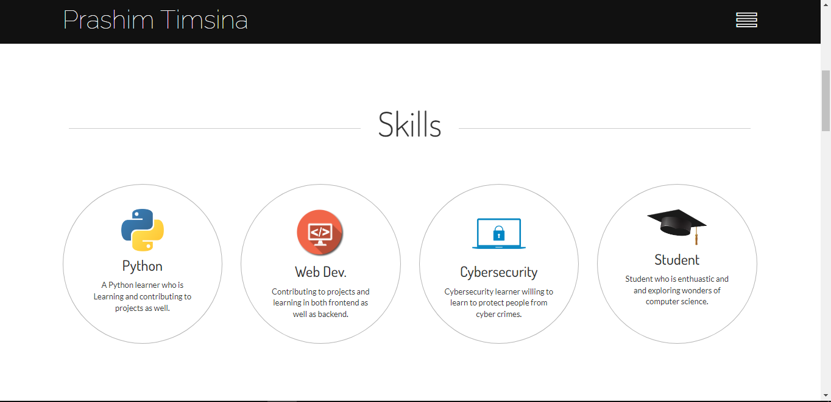 

 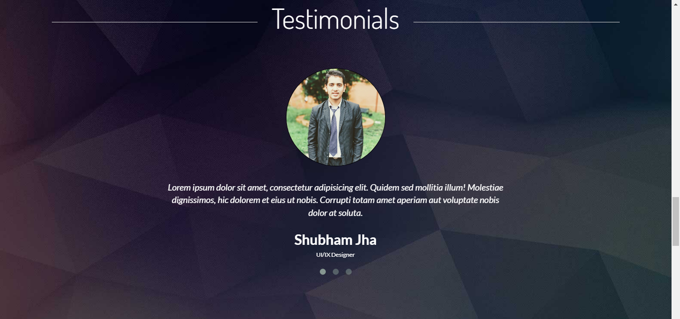 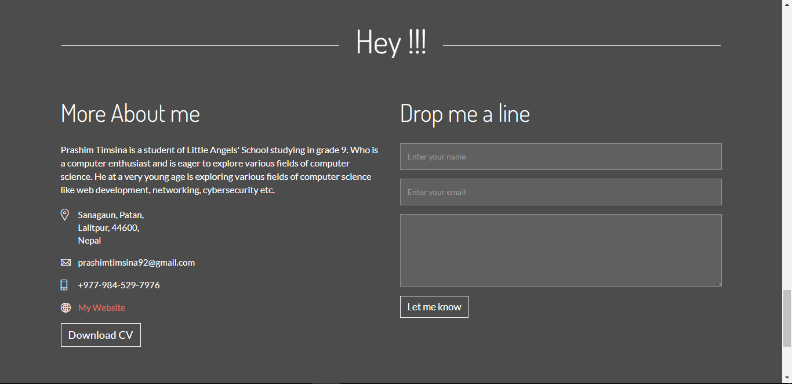



**4. Conclusion**

In conclusion, this project aims to explore the concept of web development by creating a web architecture using HTML and CSS. The project will introduce the fundamental concepts of web development, including the role of HTML and CSS in creating web pages. The web architecture will be designed to be scalable, flexible, and efficient, using best practices in web development. The project will provide valuable experience in web development and prepare participants for future projects in the field. With this project, participants can learn how to create a successful online presence by building a website using HTML and CSS.